Dependency Metrics
Code review



Done by Paula Lopes
58655

Introduction
Like we describe code as high-level/low-level, dependencies consist on low/high levels (classes,modules, packages..) depending on each other.
Generally, these occur within inheritance hierarchy (a subtype depends on its’ supertype). However, when a supertype depends on its’ dependents this creates a cyclic dependency. Having a dependency from a bottom layer to a top layer will make the system less maintainable and error-prone. Therefore, each layer should depend on layers below them and never above. Otherwise, testing the system will be more difficult, since the layers are tightly coupled and mutually dependent of each other, they cannot be tested separately.

Analysis

- Class Dependencies (CD)

When evaluating each class from a program, the structure of the assessment is:
Location of Class + Cyclic + Dcy + Dcy* + Dpt + Dpt* + PDcy + PDpt

Where:
- Cyclic (Number of cyclic class dependencies) measures, for each class X, the number of classes X depends on and depend on X
- Dcy (Number of dependencies) measures, for each class X, the number of classes X depends on
- Dcy* (Number of transitive dependencies) measures, for each class X, the number of classes X depends on, directly or indirectly
- Dpt (Number of dependants) measures, for each class X, the number of classes that depend on X
- Dpt* (Number of transitive dependants) measures, for each class X, the number of classes that depend on X, directly or indirectly
- PDcy (Number of package dependencies) measures, for each class X, the number of packages X depends on
- PDpt (Number of package dependants) measures, for each class X, the number of packages that depend on X

- Interface Dependencies (ID)
When evaluating each Interface from a program, the structure of the assessment is:
Location of Interface + Cyclic + Dcy + Dcy* + Dpt + Dpt* + PDcy + PDpt

Where:
- Cyclic (Number of cyclic interface dependencies) measures, for each Interface X, the number of interfaces X depends on and depend on X
- Dcy (Number of dependencies) measures, for each Interface X, the number of interfaces X depends on
- Dcy* (Number of transitive dependencies) measures, for each Interface X, the number of interfaces X depends on, directly or indirectly
- Dpt (Number of dependants) measures, for each Interface X, the number of interfaces that depend on X
- Dpt* (Number of transitive dependants) measures, for each Interface X, the number of interfaces that depend on X, directly or indirectly
- PDcy (Number of package dependencies) measures, for each Interface X, the number of packages X depends on
- PDpt (Number of package dependants) measures, for each Interface X, the number of packages that depend on X

- Package Dependencies (PD)
When evaluating each Package from a program, the structure of the assessment is:
Location of Package + Cyclic + PDcy + PDpt + PDpt*

Where:
- Cyclic (Number of cyclic package dependencies) measures, for each Package X, the number of packages X depends on and depend on X
- PDcy (Number of package dependencies) measures, for each Package X, the number of packages X depends on
- PDpt (Number of package dependants) measures, for each Package X, the number of packages that depend on X
- PDpt*(Number of transitive package dependants) measures, for each Package X, the number of packages that depend on X, directly and indirectly

Conclusion

From the graphics delivered regarding dependency metrics, we can conclude that any class, interface, package with a number of cylic dependencies over the average (respectively 420, 397, 112) is considered an outlier.
In jabref the vast majority of classes present trouble spots. There are around 783 classes and interfaces along with 153 packages that surpass the average. Hence, we can conclude that there are many classes, interfaces and packages that ought to be improved to decrease the existing dependencies.

This is not surprising for a project of this dimension, since the use of structural patterns commonly introduce more complexity (Adaptor, Proxy, Composite, Decorator). However, this choice also brings code smells such as Inappropriate Intimacy to play.

Trouble spots
To find a trouble spot, we can simply click on a dot in the boxplot graphics with the title ‘Cyclic’ on a critical zone (where axis of y is greater than the average value) and aftherwards we are shown the corresponding class/interface/package in the form of (row, value). On the row after the presented row, we can find the location of the trouble.
Example:
Lets say we wanted to find a class considered as a trouble spot. If we click on the first dot above the average on the cyclic graph, we are met with (2,784), which means on the row 3 the class org.jabref.gui.DialogService with a value of 784 cyclic dependencies is a trouble spot.
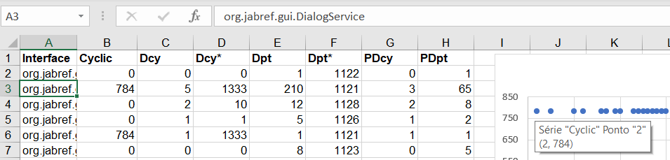

Code smells
Eventhough we didn’t officially identify the code smell of Inappropriate Intimacy, some of the code smells indentified often would lead to this particular code smell. Such as the Long Parameter List in class ArgumentProcessor from package jabref.cli.

